# CS 255 System Design Document

## UML Diagrams

### UML Use Case Diagram

### UML Activity Diagrams

**Add Driver Notes User Story**

**Log In User Story**

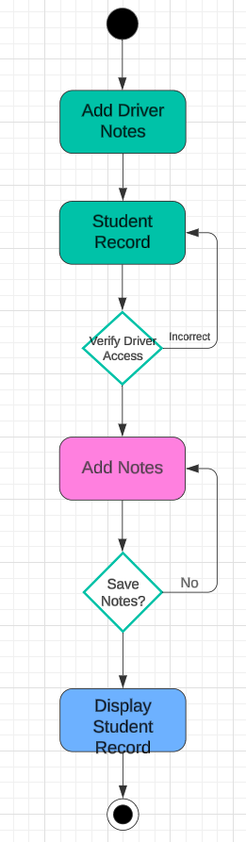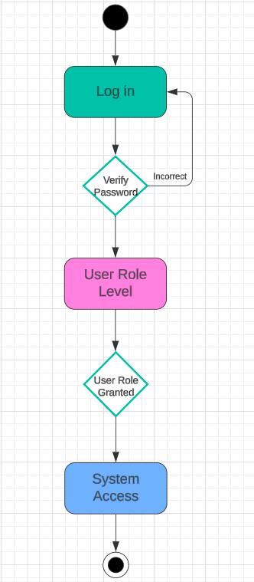

### UML Sequence Diagram

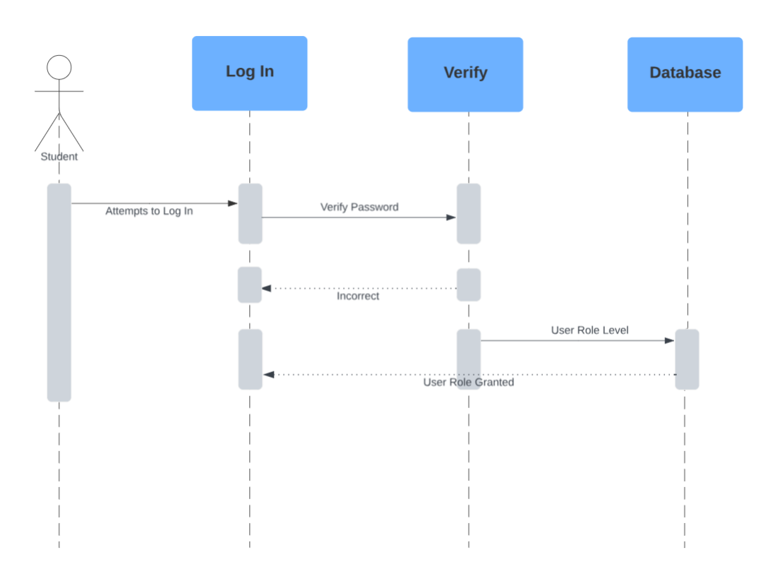

### UML Class Diagram

## Technical Requirements

1. **Hardware Requirements**
   1. Servers, cloud-based to host system
   2. Client Devices, ensure compatibility with computers, tablets, and smartphones
2. **Software Requirements**
   1. Operating System, platform independent, ensure compatibility with Windows, macOS, and Linux
   2. Web Server, cloud-based service, e.g., Amazon AWS, Google GCP, Microsoft Azure
   3. Database, cloud-based database service for storing user data and account information
   4. Programming Languages, HTML, JavaScript for front-end; Python, Java, Node.js for back-end
3. **Tools and Infrastructure**
   1. Cloud Services, cloud-services for hosting, managing the database, and other features
   2. API Services, notifications and integration with external systems, e.g., DMV
   3. Security, multi-factor authentication, HTTPS SSL encryption, server side is encrypted by cloud provider
   4. Development Tools, integrated development environment for coding and project management tools for tracking progress
4. **Performance and Scalability**
   1. Cloud-based platform updates are handled by the provider
   2. Web-based system to offer quick response times
   3. Scalable architecture to accommodate growing numbers of users and data
5. **Accessibility**
   1. Accessible across different devices and platforms, ensuring seamless access for users on desktops, tablets, and mobile devices
6. **Maintenance and Updates**
   1. regular updates to install new features, bug fixes, and updates to training content
   2. system monitoring tools for tracking performance and identifying issues